NAME _____________________________
Biological Magnification in Aquatic Ecosystems
Objectives: In this lab the students will simulate the biological magnification of a pesticide (DDT) throughout an ecosystem, and describe the large-scale environmental impacts resulting from human activity.
Background: Many forms of pollution can threaten biodiversity, but one of the most serious problems occurs when toxic compounds accumulate in the tissues of organisms. This phenomenon is referred to as BIOACCUMULATION.
When heavy metals, such as mercury and lead, and certain synthetic compounds like pesticides and herbicides are absorbed in the body along with food and water, they dissolve in the lipids of the organism and are not broken down and removed by excretion. Every time an organism eats a contaminated food small amounts of the toxin are absorbed and retained in the body. Small amounts of toxins are consumed over time and they gradually accumulate which causes toxic effects on the body. BIOLOGICIAL MAGNIFICATION occurs when increasing amounts of a harmful substance accumulate and are concentrated in the tissues of organisms at higher trophic levels in a food chain or web.

DDT was a commonly used agricultural pesticide sprayed in the 1950’s and 1960’s. It was also sprayed in “green” areas in cities like parks and golf courses to kill mosquitos because it was inexpensive, effective, and long lasting. More than 1.35 billion pounds were applied in the US before its ban in 1972. As birds of prey, like the bald eagle, osprey, and peregrine falcon ate lots of animals that had ingested DDT, they had more DDT in their system than any of the animals it ate because its body stored and accumulated the DDT. This stored DDT made it more difficult for birds to absorb calcium and the lack of calcium made their egg shells thinner. Many eggs broke before they could hatch. Because birds like eagles and osprey typically only lay 1-3 eggs at a time, losing one or two eggs due to shell thinning could have a dramatic decrease on their populations. Chemical pollutants in ecosystems don’t just accumulate in animals. DDT was detected in almost all human blood samples tested by the Center for Disease Control in 2005; although blood levels have sharply declined since DDT was banned in in the U.S. in the early 1970’s.
************************************************************************************************
MAKE A HYPOTHESIS: Remember only about 10% of the energy (kcal) is passed from one trophic level to the next because it is used up by organisms or lost as heat. So the total amount of energy DECREASES as food is passed to higher trophic levels. What do you think will happen to pollutant molecules in an organism’s body as they are passed to higher and higher trophic levels in a food chain?
_________________________________________________________________________________
_________________________________________________________________________________

Data Collection:
- As chips are passed through the food chain, fill in the data table. Determine the amount of DDT (in ppm) ingested by each organism at each trophic level in column 1 of the data table.
- Given that each phytoplankton has 200 kcal of energy stored in its tissues, determine the total energy held at each trophic level (adding all organisms up) and fill in column 2 of the data table. Remember that only 10% of energy is transferred to the next trophic level.
- In columns 3 & 4 use the following terms to name each trophic level and feeding relationship; heterotroph, primary consumer, autotroph, secondary consumer, primary producer, tertiary consumer, quaternary consumer. Some terms may be used more than once.

Procedure
Use the organism pictures provided to create a sequence that shows how a pollutant (like the pesticide DDT or BPA from plastics) might move thorough a food chain in a lake ecosystem. STACK chips onto the pictures of the consumers to show how the pesticide DDT is passed along in this food chain.
1 CHIP = 1 ppm (part per million) DDT

The circles represent the phytoplankton population in a lake. Use the chips provided to show the
incorporation of the pesticide DDT into the phytoplankton population in this lake ecosystem.
Each phytoplankton has 200 kcal of energy stored in its tissues.
1 CHIP = 1 ppm (part per million) DDT
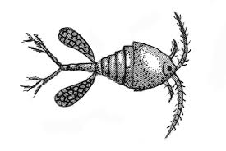
Zooplankton in the lake (population size 20) each eats 5 phytoplankton. Move the correct number of chips onto each of the zooplankton pictures. Record the amount of DDT each zooplankton has ingested on the data table.

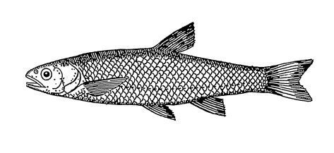
Minnows (population size 5) in the lake each eats 4 zooplankton, ingesting both the energy and the toxin stored in the zooplankton. Move the correct number of chips from the zooplankton onto the minnow pictures. Record the total amount of DDT (in ppm) ingested
by each minnow on the data table
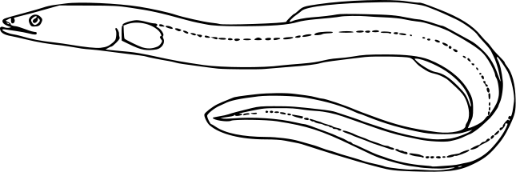
Two eels come along for dinner. Each eel eats 2 minnows. Move the correct number of chips from the minnow pictures onto the eel pictures. Write the amount of DDT ingested by each eel on the data table.

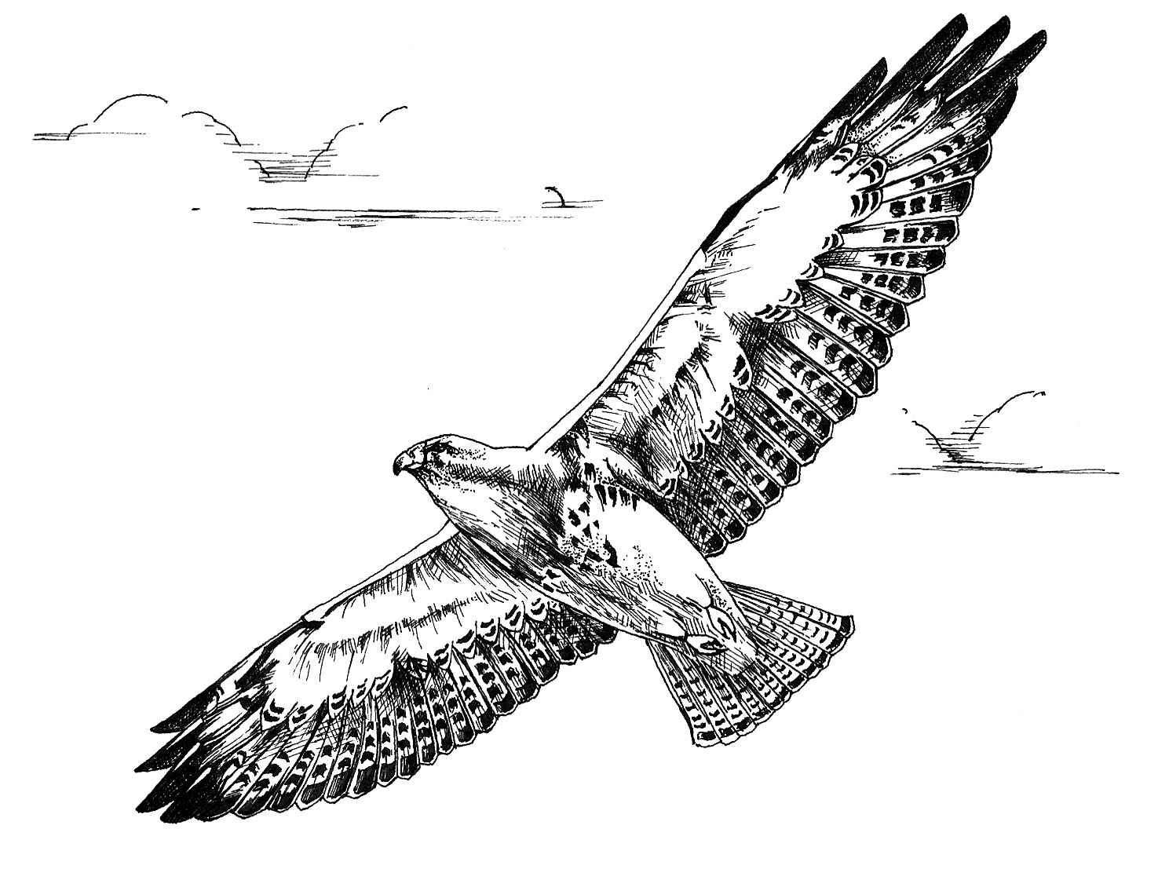
Finally, an osprey swoops in and eats both eels! Move the correct number of chips from the eel pictures onto the osprey pictures. Calculate and then write the total amount of DDT (in ppm) ingested by the osprey onto the data table.

Data Table:
 | Amount of DDT in each organism  (ppm) |  | Total Energy (kcal)  in each  trophic level  Take energy in previous level X 0.1 | AUTOTROPH?  OR  HETEROTROPH? | TROPHIC  LEVEL  Producer or consumer?  Quaternary, tertiary, secondary, primary?
Phytoplankton (100)  200 kcal energy/organism |  |  | 200 kcal X 100  = 20,000 kcal
Copepod (20) (zooplankton)
Eat 5 phytoplankton
Minnow (6)
Eat 4 zooplankton

Eel (2)
Eat 2 minnows
Osprey (1)
Eat 2 eels

Analysis and Conclusion:
- In the space below draw an ENERGY PYRAMID showing the total energy at each trophic level. Remember only 10% of the energy passes from one trophic level to the next.

- In the space below draw a PYRAMID showing DDT concentration (in ppm) in organisms at each trophic level as the chemical moves up the food chain.

3. COMPARE THE TWO PYRAMIDS.
What happens to the total amount of energy (kcals) as you move to higher and higher trophic levels?
How is this different from the concentration of DDT as you move to higher and higher trophic levels?
- Remember what you learned about biogeochemical cycles in the last chapter. How do you think pesticides like DDT get from where they are sprayed into wetlands and lakes?

- Which organism had the LOWEST concentration of DDT in its body?

- Which had the GREATEST concentration of DDT in its body? How many times more?

- During the late 1950’s-early 1960’s people living near Minamata Bay, Japan became ill with a crippling neurological disease after eating fish caught in the bay. This was later discovered to be caused by mercury being dumped into the ecosystem there. Describe how humans could end up accumulating chemicals like DDT, Mercury, or BPA in their bodies.

- MAKE A CONNECTION: Remember what you learned about hydrophobic and hydrophilic molecules back in chapter 1. Many organic pesticides like DDT are stored and accumulate in FAT in body tissues. Make a prediction about DDT and BPA molecules. Do you think they are hydrophobic or hydrophilic molecules? EXPLAIN your answer.

- What is biological magnification?

- Use your computer to research some alternatives to spraying harmful chemical-based pesticides.
DON’T JUST NAME IT. DESCRIBE TWO (2) alternatives you find.
1.

2.

MODIFIED FROM: http://www.cpalms.org/Public/PreviewResourceLesson/Preview/128825

