EVOLUTION REVIEW NAME __________________________

1. Name 3 conditions required to maintain genetic equilibrium under the HARDY-WEINBERG PRINCIPLE.

_________________________________________

_________________________________________

_________________________________________

2. TRUE FALSE There are times and places when all of the above exist and evolution doesn’t happen.

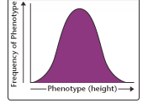
3. Traits that show this kind of distribution (like lima bean length, human intelligence, or skin color) and are determined by more than one gene are
called _____________________,

4. Name the two geologists whose ideas about the age of the earth and processes that shaped it influenced Darwin.

____________________________ & ______________________________

5. Match the kind of selection with the graph shown below.
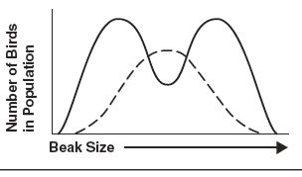
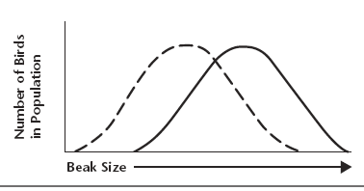
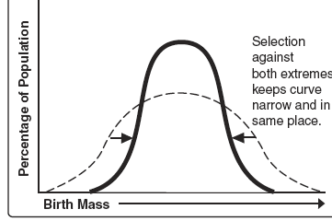
A. B. C.
.
DIRECTIONAL ______
DISRUPTIVE ______
STABILIZING ______

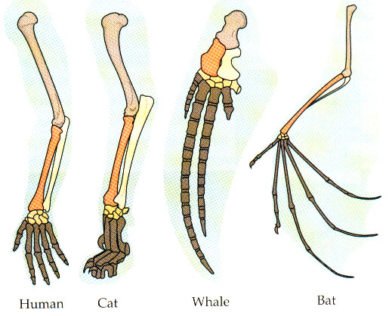
6. These are examples of________________ structures because they come from the same embryonic tissue.

7. Name 5 kinds of evidence that support Darwin’s Theory of Evolution.

___________________________________________

___________________________________________

___________________________________________

___________________________________________

____________________________________________
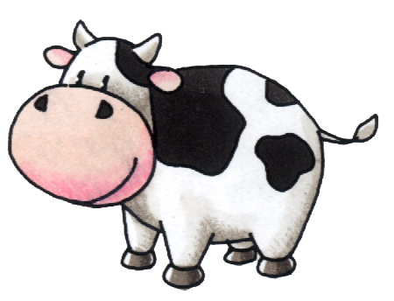

8. Breeding cows that give the most milk or the fastest horses
is an example of ____________________

9. Darwin’s idea that each living species has descended with changes from other species over time is called ______________ ______ _____________

10. The ability of an organism to survive in its environment is called ______________.

11. Lamarck proposed that organisms could alter the size or shape of their bodies through use or disuse and pass these traits on to their offspring. This idea is called ____________________.
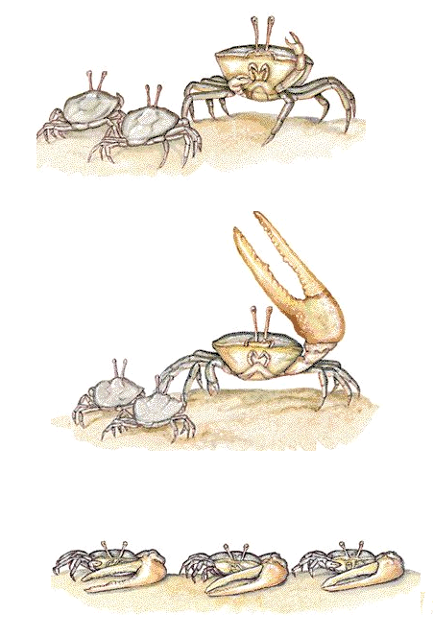

12. Tell why he was incorrect.

13. Genetic drift happens in populations that are __________________ Small Large

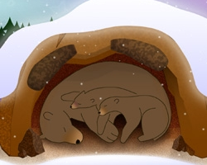
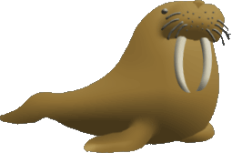
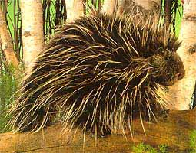

14. Physical characteristics like walrus tusks and porcupine quills or behavioral characteristics like hibernating and living in herds are examples of inherited traits called _____________________that help an organism to survive and reproduce in its environment.

15. In addition to observing living organisms, Darwin studied the preserved remains of ancient organisms called ____________________.

16. Name the island where Darwin observed finches, iguanas, and turtles that led to his Theory of Evolution.

17. A well-supported testable explanation of phenomena that have occurred in the natural world
is called a _______________.

18. The process in which organisms that are better suited to their environment survive and reproduce is called ________________ ____ ____ ___________.

19. A ______________ _____________ consists of all the different alleles that are present in a population.
20. In genetic terms, evolution is a change in the _________________ _______________ of alleles in a population.
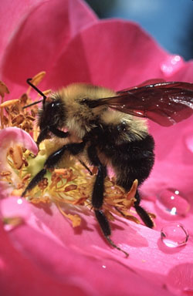

21. Name the type of macroevolution in which two organisms evolve in response to changes in each other.

_________________________________

22. Which of the following is NOT part of Darwin’s Theory of Evolution?
A. Organisms in a population show a natural variation in heritable traits.
B. Organisms must compete for resources because organisms produce more offspring than can survive.
C. Individuals best suited to their environment will survive and reproduce most successfully passing on their traits.
D. Species alive today are descended with modification from ancestral species that lived in the distant past.
E. Evolution unites all organisms into a single “tree of life”
F. Acquired traits can be inherited.

23. ________________ organs are reduced in size and no longer functional.

24. Give an example of #23. ______________________________________
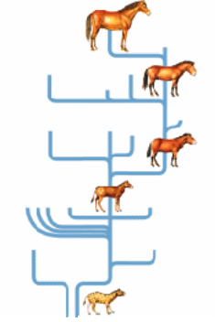

25. Name the kind of macroevolution in which populations show a pattern of long stable periods interrupted by brief periods of rapid change.

___________________________________

26. A situation in which allele frequencies change as a result of the migration of a small subgroup of the population is known as the
________________________________________.

27. Name the two scientists who came up with a mathematical equation to express the frequencies of alleles in a population.
__________________________ & ____________________________

28. Name the naturalist whose ideas about evolution were similar to Darwin’s and who prompted Darwin to publish his book “On the Origin of Species”.

______________________________________

29. Another name for divergent evolution is __________________________________.

30. Tell one reason why human chromosome #2 suggests a relationship between humans and chimpanzees.

____________________________________________________________

