MUTATIONS and GENE REGULATION NAME __________________________ f18
Chapter 12-4

MATCH THE MUTATION WITH ITS DESCRIPTION

FRAMESHIFT POINT DUPLICATION INSERTION INVERSION

TRANSLOCATION SUBSTITUTION DELETION POLYPLOIDY

___________________________ Change in one or just a few nucleotide in the code

___________________________ Deletion or insertion that causes the reading frame on the remaining
nucleotides to be shifted over and read incorrectly

___________________________ One nucleotide in code is replaced by another

___________________________ Complete set of chromosomes fails to separate resulting in 3N or 4N organisms

___________________________ Piece of DNA is broken off and lost

___________________________ Piece of DNA breaks off and reattaches to another
NON-homologous chromosome

___________________________ Piece of DNA breaks off, flips, and reattaches so that it reads backwards

___________________________ Piece of DNA is added to the code

___________________________ Extra copies of part of a chromosome are made

****************************************************************************************

COMPLETE THE FOLLOWING COMPARISON CHART
TYPE OF MUTATION | PICTURE
 | 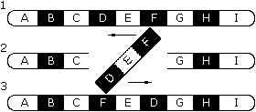
 | 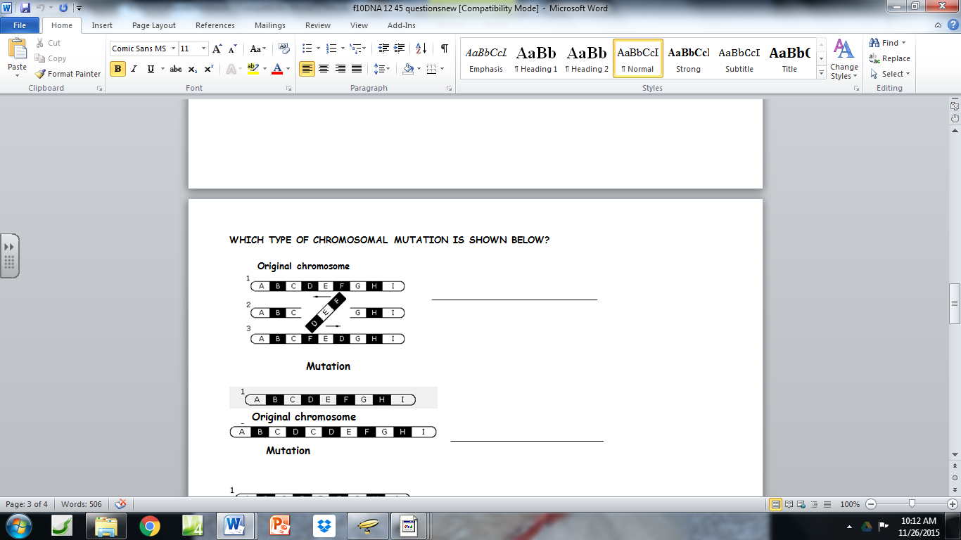
 | 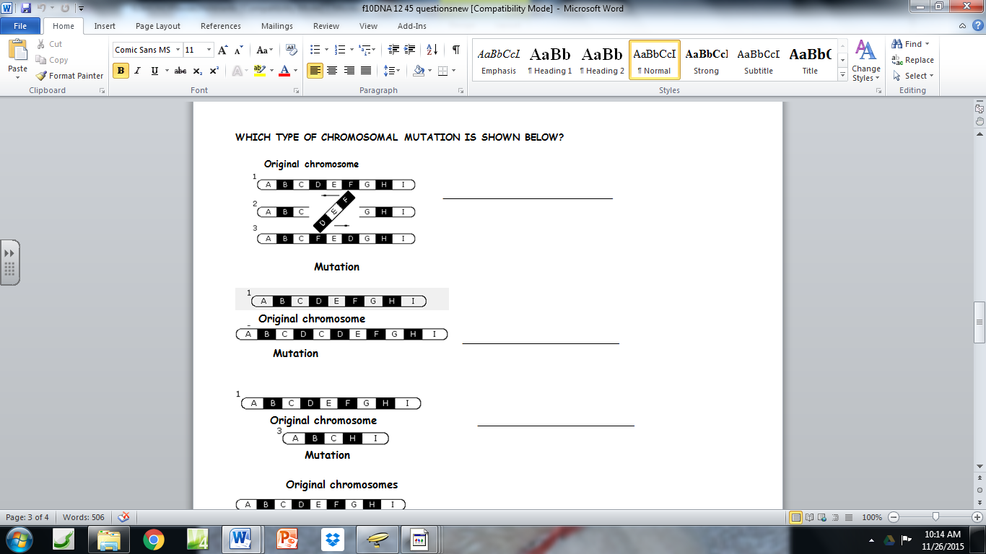
 | 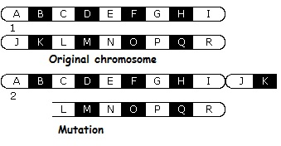
 | 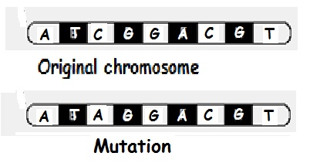
 | 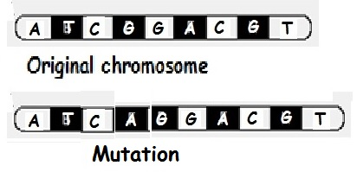

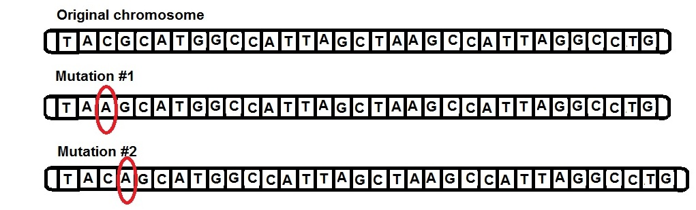

Mutation #1 is an example of which type of mutation you learned about? ________________________
Mutation #2 is an example of which type of mutation you learned about? ________________________

Both of these mutations put an Adenine (A) where it doesn’t belong in the DNA code.
How do EACH of these change the message produced?

Mutation #1__________________________________________________________________________

Mutation #2__________________________________________________________________________

Which of these would cause more disruption in the amino acid sequence of the protein this gene codes for? EXPLAIN YOUR ANSWER

___________________________________________________________________________________

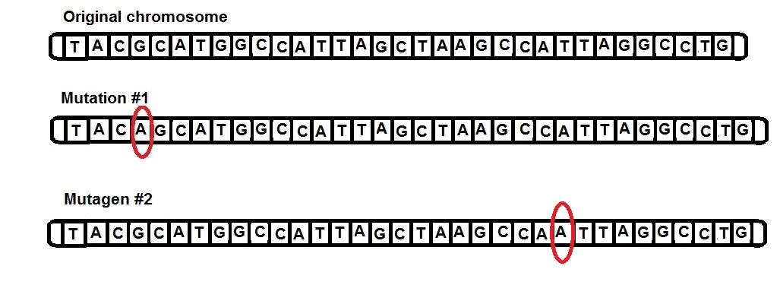
Mutation #1 and #2 above are both FRAMESHIFT mutations.
How do frameshift mutations change the message produced?
__________________________________________________________________________________

Explain why a frame shift mutation at the beginning of a gene sequence (#1) is more damaging than nearer the end of a sequence (#2).

__________________________________________________________________________________

__________________________________________________________________________________

