NAME _________________________ f17

HONORS BIO-WHAT SHOULD I KNOW ABOUT DNA, RNA, & PROTEINS

NAME THE PEOPLE:
_____________________ & ____________________ used ______________________’s X-ray images to help them figure out the structure of DNA.

SUBUNIT | SUBUNIT NAME | SUBUNIT PICTURE
PROTEINS
NUCLEIC ACIDS (DNA & RNA)

 | DNA | RNA
Double stranded? Or
Single stranded?
Nitrogen bases it contains
Nitrogen base missing
Sugar it contains?
Function?
Where found in eukaryotic cells?

Name the 3 parts of a nucleotide molecule:
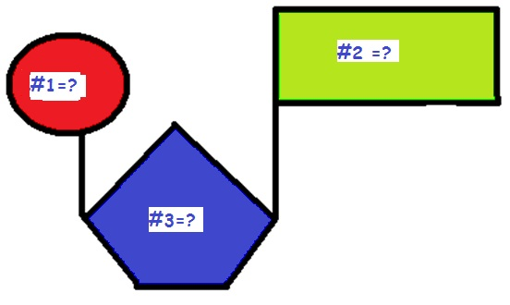
#1 = _____________________
#2 = _______________________
#3 = ________________________

What is a purine? _______________________________________________________________________
What is a pyrimidine? ____________________________________________________________________
What is the shape of a DNA molecule? _____________________________________

Which molecules for the backbone of the DNA molecule? _____________________ & _____________________

What molecules form the “steps of the ladder”? __________________________________

What kind of bond holds the nitrogen bases together in the middle of the strand? _________________________
What does it mean when we say a DNA strand is “anti-parallel”?
Chargaff’s rule says: A always = ______; G always = _____
What are histones?
What is a nucleosome?
 | CHROMATIN | CHROMOSOMES
Tightly packed? OR loosely packed?

In dividing? OR non-dividing cells?
Easy to read & copy? OR
Easy to move?

What is the difference?
 | REPLICATION | TRANSCRIPTION | TRANSLATION
WHAT HAPPENS?
WHERE IT HAPPENS?

What is the Central Dogma of molecular biology that shows how information is passed in cells?

___________ ___________ _______________

What enzyme adds nucleotide subunits to the strand when DNA is copied? _________________________________
What enzyme adds nucleotide subunits when RNA is made from DNA? ____________________________________
The place on the DNA where RNA POLYMERASE attaches to start transcription = __________________________

 | Messenger RNA (m-RNA) | Ribosomal RNA (r-RNA) | Transfer RNA (t-RNA)
Job during translation
(protein synthesis)

SHAPE?

Which kind of RNA has a CODON? __________________
Each CODON in an m-RNA message is made of ______ nucleotides.
Each CODON in an m-RNA message represents _______ amino acid.
Which kind of RNA has an ANTICODON? __________________
What kind of molecules make up ribosomes? ____________________ & ________________
Which cell part makes r-RNA? _________________________
Which cell part makes proteins? _________________________

The ribosome makes sure the amino acid is put in the right spot by matching the__________________ on the t-RNA with the _________________ on the m-RNA
After an m-RNA message is transcribed from the DNA it is edited. ______________ are cut out and _______________ stay in the message that gets sent to the ribosomes.
DNA that doesn’t code for proteins is called _____________________
Give an example: ________________________________

Name the woman scientist who discovered transposons? ___________________________________

What is a transposon (jumping gene)?
Be able to use an mRNA decoder wheel to determine the amino acid sequence if given an mRNA message.
What is an operon?

Operons are found in PROKARYOTES EUKARYOTES (circle one)
In an operon, what attaches to the promoter site when the gene is turned ON? _________________________
In an operon, what attaches to the operator site when the gene is turned OFF? _________________________

What is a repressor?

When a repressor protein is attached to the operator, the gene is turned ON OFF (circle one)

What is a TATA box?

What is an enhancer region?

What role do hox genes play in differentiation and growth and development of embryos?

TATA boxes, enhancer regions, and hox genes are found in PROKARYOTES EUKARYOTES (circle one)

What is a mutation?

What causes mutations?

How are GENE mutations different from CHROMOSOMAL mutations?

What is a frameshift mutation?

Why is a frameshift mutation at the beginning of the code more damaging than one at the end?

TYPE OF MUTATION | DESCRIPTION | PICTURE
 |  | 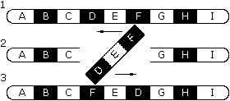
 |  | 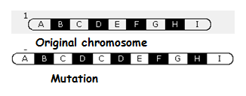
 |  | 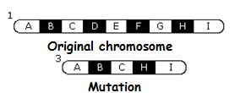
 |  | 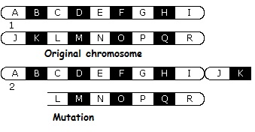
 |  | 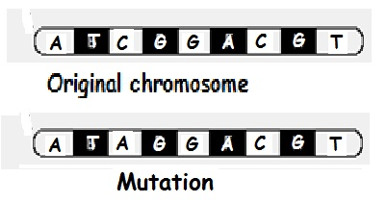
 |  | 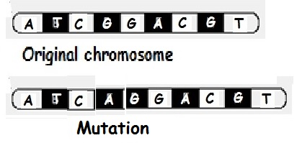

What is polyploidy?

Polyploidy in plants makes them ________________________________; polyploidy in humans is _______________

The study of gene expression caused by environmental factors that switch genes on and off instead of being caused by changes in the DNA sequence is called _________________________

What chemical tag is added to DNA during genomic imprinting? ______________
Adding methyl tags to DNA turns genes OFF ON (circle one)

What is differentiation?
What makes a blood cell different from a bone or muscle cell?
What is a Barr body?

What are some environmental conditions that can influence the chemical tags on genes?

