NAME ____ANSWER KEY_________ f15

WHAT SHOULD I KNOW ABOUT DNA, RNA, & PROTEINS

NAME THE PEOPLE:
__JAMES WATSON____ & _FRANCIS CRICK_____ used _Rosalind Franklin’s X-ray images to help them figure out the structure of DNA.

SUBUNIT | SUBUNIT NAME | SUBUNIT PICTURE
PROTEINS | AMINO ACID | 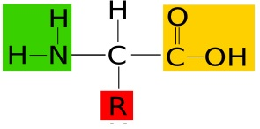
NUCLEIC ACIDS (DNA & RNA) | NUCLEOTIDE | 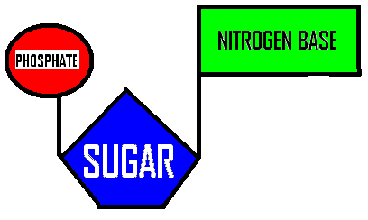

 | DNA | RNA
Double stranded? Or  Single stranded? | DOUBLE | SINGLE
Nitrogen bases it contains | A, T, G, C | A, U, G, C
Nitrogen base missing | No U | No T
Sugar it contains? | DEOXYRIBOSE | RIBOSE
Function? | Genetic code molecule | Carry info from DNA to cell and  Protein synthesis
Where found in eukaryotic cells? | In nucleus | Made in nucleus; used in cytoplasm
Name the 3 parts of a nucleotide molecule:
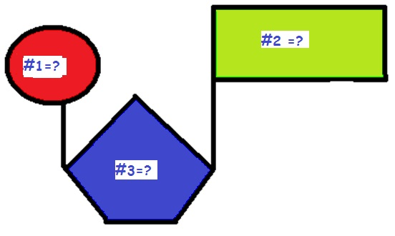
#1 = __PHOSPHATE__________
#2 = __SUGAR_________
#3 = __NITROGEN BASE_________

What is a purine? NITROGEN BASE WITH 2 RINGS
What is a pyrimidine? NITROGEN BASE WITH ONE RING

What is the shape of a DNA molecule? DOUBLE HELIX= “TWISTED LADDER”
Which molecules for the backbone of the DNA molecule? PHOSPHATES__ & __SUGARS_______
What molecules form the “steps of the ladder”? ___NITROGEN BASES______________________
What kind of bond holds the nitrogen bases together in the middle? ___HYDROGEN BONDS____

What does it mean when we say a DNA strand is “anti-parallel”? TWO DNA STRANDS RUN IN OPPOSITE DIRECTIONS
Chargaff’s rule says: A always = _T_; G always = __C__

What are histones?
PROTEINS DNA WRAPS AROUND TO PACK TIGHTLY INTO CHROMOSOMES
What is a nucleosome?
BEADLIKE STRUCTURE FORMED WHEN DNA WRAPS AROUND HISTONES

 | CHROMATIN | CHROMOSOMES
Tightly packed? OR loosely packed? | LOOSELY PACKED | TIGHTLY PACKED
In dividing? OR non-dividing cells? | IN NON-DIVIDING CELLS | IN DIVIDING CELLS
Easy to read & copy? OR  Easy to move? | EASY TO READ & COPY | EASY TO MOVE

What is the difference?
 | REPLICATION | TRANSCRIPTION | TRANSLATION
WHAT HAPPENS? | DNA → DNA  MAKING A DNA COPY | DNA → RNA  USING DNA TO MAKE RNA MESSAGE | RNA → PROTEIN  PROTEIN SYNTHESIS
WHERE IT HAPPENS? | NUCLEUS IN EUKARYOTES | NUCLEUS IN EUKARYOTES | CYTOPLASM

What is the Central Dogma of molecular biology that shows how information is passed in cells?

___DNA___ __RNA____ __PROTEIN______

What enzyme adds nucleotide subunits to the strand when DNA is copied? __DNA POLYMERASE____________
What enzyme adds nucleotide subunits when RNA is made from DNA? ____RNA POLYMERASE_____________
The place on the DNA where RNA POLYMERASE attaches to start transcription = ___PROMOTER_________________

 | Messenger RNA (m-RNA) |  | Ribosomal RNA (r-RNA) |  | Transfer RNA (t-RNA)
Job during translation  (protein synthesis) | HOLDS INFORMATION  TO MAKE PROTEIN | 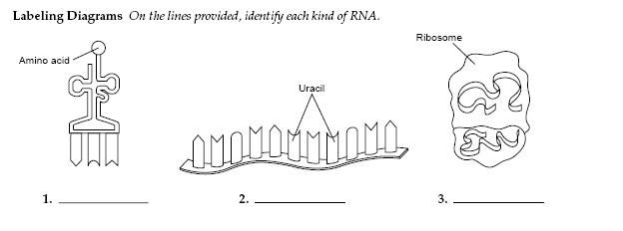  COMBINES WITH PROTEINS TO MAKE RIBOSOMES |  | ADDS AMINO ACIDS IN CORRECT ORDER TO MAKE  POLYPEPTIDE CHAIN
SHAPE?

Which kind of RNA has a CODON? ___m-RNA___
Which kind of RNA has an ANTICODON? __t-RNA____
What kind of molecules make up ribosomes? ___PROTEINS______ & ___r-RNA__________
Which cell part makes r-RNA? ___NUCLEOLUS__
Which cell part makes proteins? _RIBOSOMES______________

The ribosome makes sure the amino acid is put in the right spot by matching the ANTI-CODON___ on the t-RNA with the ___CODON______ on the m-RNA
After an m-RNA message is transcribed from the DNA it is edited. _INTRONS__ are cut out and ___EXONS________ stay in the message that gets sent to the ribosomes.
DNA that doesn’t code for proteins is called __”JUNK DNA”_______
Give an example: _TELOMERES, TRANSPOSONS, OPERATOR, PROMOTER, ENHANCER SITES_______

Name the woman scientist who discovered transposons? ___BARBARA McCLINTOCK__________

What is a transposon (jumping gene)? REGION OF DNA THAT CAN JUMP FROM ONE LOCATION TO ANOTHER WHICH IS THOUGHT TO BE INVOLVED IN INCREASING MUTATIONS IN CELLS

Be able to use an mRNA decoder wheel to determine the amino acid sequence if given an mRNA message.

What is an operon? GROUP OF GENES THAT WORK TOGETHER AND ARE CONTROLLED BY ONE OPERATOR/PROMOTER REGION

Operons are found in PROKARYOTES EUKARYOTES (circle one)
In an operon, what attaches to the promoter site when the gene is turned ON? __RNA POLYMERASE_________
In an operon, what attaches to the operator site when the gene is turned OFF? __REPRESSOR________________

What is a repressor? PROTEIN THAT ATTACHES TO OPERATOR TO TURN GENES OFF

When a repressor protein is attached to the operator, the gene is turned ON OFF (circle one)

What is a TATA box? REGION OF DNA WITH MANY A’s AND T’s THAT HELPS POSITION RNA POLYMERASE
What is an enhancer region? REGION IN FRONT OF EUKARYOTIC GENES WHERE REGULATORY PROTEINS CAN JOIN TO INCREASE TRANSCRIPTION

What is differentiation? PROCESS BY WHICH STEM CELLS CHANGE TO BECOME DIFFERENT KINDS OF CELLS WITH DIFFERENT FUNCTIONS DUE TO TURNING ON/OFF DIFFERENT GENES

What role do hox genes play in differentiation and growth and development of embryos?
GENES THAT CONTROL THE GROWTH, DEVELOPMENT, AND LOCATION OF BODY PARTS IN DEVELOPING EMBRYOS

TATA boxes, enhancer regions, and hox genes are found in PROKARYOTES EUKARYOTES (circle one)

What is differentiation?
PROCESS BY WHICH EMBRYONIC STEM CELLS CHANGE TO BECOME DIFFERENT KINDS OF CELLS WITH DIFFERENT FUNCTIONS
What is a mutation? CHANGE IN THE GENETIC CODE

What causes mutations? MISTAKES DURING COPYING DNA, MISTAKES DURING CELL DIVISION, CARCINOGENS LIKE CIGARETTE SMOKE, RADIATION, VIRUSES

How are GENE mutations different from CHROMOSOMAL mutations?
GENE MUTATIONS – CHANGE IN A SINGLE GENE
CHROMOSOMAL MUTATIONS- CHANGE IN WHOLE CHROMOSOME

What is a frameshift mutation?
MUTATION (ADDITION OR DELETION NOT IN GROUPS OF 3) THAT CAUSES THE READING FRAME TO SHIFT OVER

Why is a frameshift mutation at the beginning of the code more damaging than one at the end?
EARLY FRAMESHIFTS CHANGE MORE OF THE CODE SO MORE OF THE PROTEIN IS CHANGED
TYPE OF MUTATION | DESCRIPTION | PICTURE
INVERSION | PIECE OF DNA BREAKS OFF, FLIPS, AND REATTACHES SO THAT IT READS BACKWARDS | 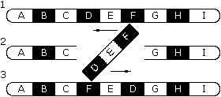
DUPLICATION | EXTRA COPIES OF PART OF A CHROMOSOME ARE MADE  (This could also cause a frameshift) | 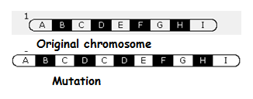
DELETION | PIECE OF DNA IS REMOVED AND LOST (This could also cause a frameshift) | 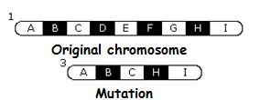
TRANSLOCATION | PIECE OF DNA BREAKS OFF AND REATTACHES TO ANOTHER  NON-HOMOLOGOUS CHROMOSOME | 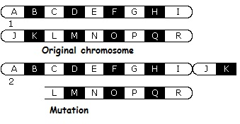
SUBSTITUTION | ONE NUCLEOTIDE IN CODE IS REPLACED BY ANOTHER  (A REPLACES C) | 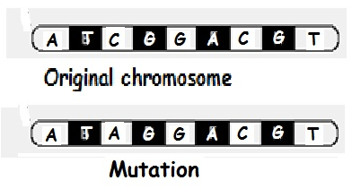
INSERTION | EXTRA PIECE OF DNA IS ADDED  (A ADDED TO SEQUENCE)  (This could also cause a frameshift) | 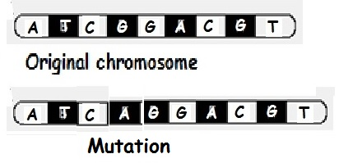
DUPLICATIONS, DELETIONS, INSERTIONS CAN ALSO CAUSE FRAMESHIFT MUTATIONS

What is polyploidy? CONDITINO IN WHICH CELLS HAVE MORE THAN TWO SETS OF EACH CHROMOSOME
(MOST BODY CELLS ARE DIPLOID (2n) ; POLYPLOIDS ARE 3n, 4n, 8n etc)

Polyploidy in plants makes them _BIGGER AND STRONGER____; polyploidy in humans is __LETHAL____

