NAME ___________________________
BLOOD TYPING LAB
The system used to classify human blood is called the “ABO” system. Dr. Karl Landsteiner, an Austrian physician, received the Nobel Prize in physiology for this discovery in 1930. Surface GLYCOPROTEINS on red blood cells determine an individual’s blood type. These surface proteins are called ANTIGENS since they stimulate an immune response
Individuals with A type glycoproteins (antigens) have type A blood. Individuals with B type glycoproteins have B type blood. Individuals with both A and B glycoproteins have AB type blood. Individuals with neither A or B glycoproteins have type O blood.

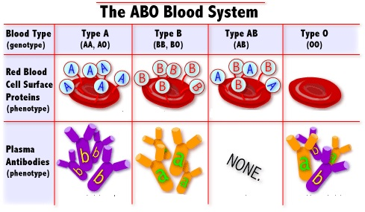
Blood plasma has circulating proteins called ANTIBODIES that are produced by the immune system AGAINST antigens the body recognizes as “foreign”.
For example individuals WITH A type glycoproteins (ANTIGENS) produce
ANTI-B ANTIBODIES.

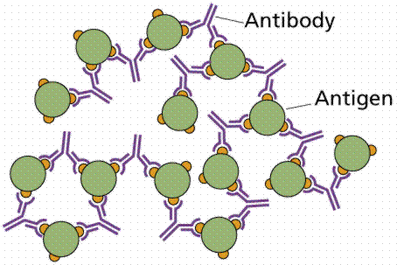
Blood typing is performed using “ANTISERUM” containing ANTIBODIES. ANTIGENS on the surface of blood cells react with ANTIBODIES causing the cells to stick together and CLUMP. This is called AGGLUTINATION

Type A blood agglutinates with ANTI-A serum
DIRECTIONS:
1. Place 5 drops of Patient 1 Simulated Blood Sample in each well on blood typing tray.
2. Add 3 drops of ANTI-A Simulated Antiserum to Well A in the blood typing tray.
3. Use a BLUE stirring stick to mix the simulated blood and antiserum for 10 seconds.

4. Add 3 drops of ANTI-B Simulated Antiserum in Well B in the blood typing tray.
5. Use a YELLOW stirring stick to mix the simulated blood and antiserum for 10 seconds.
6. Add 3 drops of ANTI-Rh Simulated Antiserum in Rh well in blood typing tray.
7. Use a GREEN stirring stick to mix the simulated blood and antiserum for 10 seconds.
Clumping indicates that the simulated blood sample contains antigens that reacted against the antibodies in the typing serum used.
8. Carefully examine each well to determine if the simulated
blood in each well has clumped or AGGLUTINATED.
9. Record results and observations in the Data Table below.
10. REPEAT Steps 1-9 to type each of the remaining patient simulated blood samples.
Simulated  Blood  Sample | Agglutination  in well A?  YES/NO | Agglutination  in well B?  YES/NO | Agglutination  in well Rh?  YES/NO | BLOOD  TYPE | DRAW A PICTURE TO SHOW WHAT A BLOOD CELL FROM THIS PATIENT LOOKS LIKE
Patient 1

Patient 2

Patient3

Patient 4

FOLLOW UP QUESTIONS:
Proteins (like glycoproteins) that cause an immune response are called _____________________
The clumping reaction seen in this lab when
antibodies and antigens combine is called __________________________
Based on your results which ABO blood type(s) can:
Patient #1 receive safely?____________________________________
Patient #2 receive safely?____________________________________
Patient #3 receive safely?____________________________________
Patient #4 receive safely?____________________________________
What kind of ANTIBODIES does Patient #4 PRODUCE? ______________________________
Which patient is considered a universal donor? _________________________
Explain what would happen to a type O patient if he/she receives type A or B blood?
__________________________________________________________________________

PRELAB: MODELING BLOOD TYPING
“TOOBERS” = red blood cells
PUSH PINS = GLYCOPROTEINS
BLUE=A
YELLOW = B
GREEN = Rh⁺

PIPE CLEANERS =ANTIBODIES
BLUE = Anti-A
YELLOW = Anti-B
GREEN = Anti-Rh

WORK WITH YOUR GROUP TO MAKE THE FOLLOWING MODELS AND SHARE YOUR RESULTS.
Make a MODEL to show what blood cells from a person with A negative blood looks like.
DRAW it below.

Make a MODEL to show what will happen in the blood typing well when A negative blood is mixed with
ANTI-A antiserum. DRAW it below.

What will happen in lab when A negative blood is mixed with ANTI-A antiserum? CLUMP NO CLUMP
What will happen in lab when A negative blood is mixed with ANTI-B antiserum? CLUMP NO CLUMP
What will happen in lab when A negative blood is mixed with ANTI-Rh antiserum? CLUMP NO CLUMP
_________________________________________________________________________
Make a MODEL to show what blood cells from a person with B positive blood looks like.
DRAW it below.

Make a MODEL to show what will happen in the blood typing well when B positive blood is mixed with
ANTI-Rh antiserum. DRAW it below.

What will happen in lab when B positive blood is mixed with ANTI-A antiserum? CLUMP NO CLUMP
What will happen in lab when B positive blood is mixed with ANTI-B antiserum? CLUMP NO CLUMP
What will happen in lab when B positive blood is mixed with ANTI-Rh antiserum? CLUMP NO CLUMP
__________________________________________________________________________

Make a MODEL to show what blood cells from a person with O negative type blood looks like.
DRAW IT BELOW.

Make a MODEL to show what will happen in the blood typing well when O negative blood is mixed with
ANTI-A OR ANTI-B antiserum. DRAW it below.

What will happen in lab when O negative blood is mixed with ANTI-A antiserum? CLUMP NO CLUMP
What will happen in lab when O negative blood is mixed with ANTI-B antiserum? CLUMP NO CLUMP
What will happen in lab when O negative blood is mixed with ANTI-Rh antiserum? CLUMP NO CLUMP
__________________________________________________________________________
Make a MODEL to show what blood cells from a person with AB positive blood look like.
DRAW it below.

Make a MODEL to show what will happen in the blood typing well when AB positive blood is mixed with
ANTI-A OR ANTI-B antiserum. DRAW it below.

What will happen in lab when AB positive blood is mixed with ANTI-A antiserum? CLUMP NO CLUMP
What will happen in lab when AB positive blood is mixed with ANTI-B antiserum? CLUMP NO CLUMP
What will happen in lab when AB positive blood is mixed with ANTI-Rh antiserum? CLUMP NO CLUMP

************************************************************************************************

CHECK FOR UNDERTSTANDING:
If a person has AB negative blood type which antisera (plural of serum) will they react to ?
ANTI-A ANTI-B ANTI-Rh NONE (Circle all that are true)

If a person has O positive blood type which antisera will they react to?

ANTI-A ANTI-B ANTI-Rh NONE (Circle all that are true)

