HONORS GENETICS REVIEW ANSWERS
1. Gregor Mendel
2. allele
3. B-heterozygous
4. F₂
5. heredity
6.dominant
7. Mm
8. pure-breeding
9.A-complete dominance
10. TT
11. tt
12. B incomplete dominance
13. phenotype
14. recessive
15. C-codominance
16. hybrid
17. F₁
18. D-heterozygous
19. polygenic
20. genetics
21. E-B type cells only have B glycoproteins
22. human height, intelligence, skin color, hair color
23. AB (positive)
24. multiple allele
25. trait
26. glycoproteins
27. Tt
28. yy (two lower case y)
29. Tt
30. RR
31. Test cross
32. Homozygous recessive
33.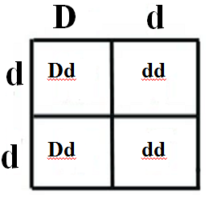 | GENOTYPE/PHENOTYPE  50% Dd (hearing)  50% dd (deaf)
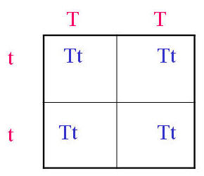
34.
GENOTYPE- 100 % Tt
PHENOTYPE- all tongue rollers
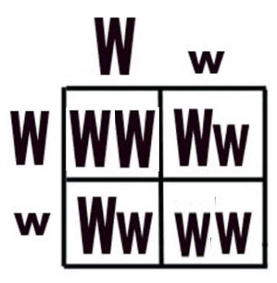  35. |  | GENOTYPE  25%-WW  50% - Ww  25% - ww  PHENOTYPE  75% Widow's peak (WW & Ww)  25% NO widow's peak (ww)
36. XX
37. males
38. autosomes
39. epigenetics
40. methyl groups

