NAME _______________________

CAN YOU FIND IT IN YOUR BINDER?
WARM UP SEMESTER TEST- Bio II
PHOTOSYNTHESIS Chapter 9
1. Name the products of the Calvin cycle.

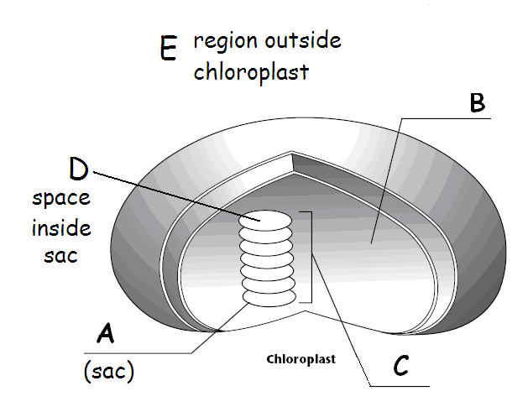  Image from: BIOLOGY by Miller and Levine | 2. Name A
3. Which gas is given off by plants during photosynthesis?
4. Which ion moves through the ATP synthase tunnel and provides the energy to attach a phosphate onto ADP to make ATP?
RESPIRATION Chapter 8
5. Which of the following is the correct sequence of events during cellular respiration?
A. glycolysis → fermentation → Krebs cycle
B. Krebs cycle → Electron Transport → glycolysis
C. glycolysis → Krebs cycle → Electron Transport
D. Electron Transport → Krebs cycle → glycolysis
6. What happens during glycolysis?
7. During cellular respiration which molecule is the last electron acceptor at the end of the Electron Transport chain?

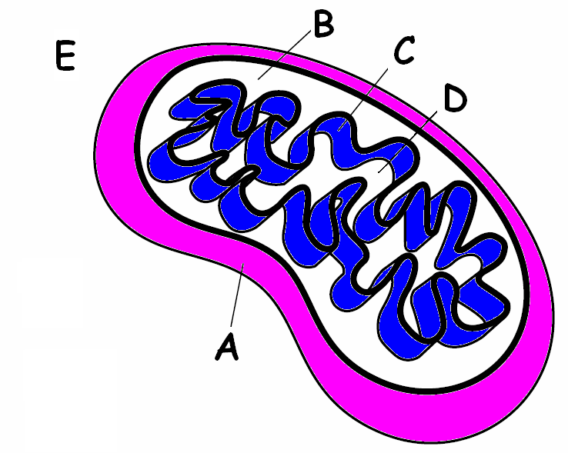  Image modified from BIOLOGY by Miller and Levine | 8. Where does the Kreb's cycle happen?
BIOSPHERE Chapter 3
9. Food chains always have a(n)______________ on their first trophic level.
10. Process in which bacteria convert nitrates into nitrogen gas and release it into the atmosphere.
11. Name the biogeochemical cycle which includes fossil fuels as a sink.
12. Where do humans get the nitrogen they need to make proteins and DNA?
HUMAN IMPACT Chapter 6
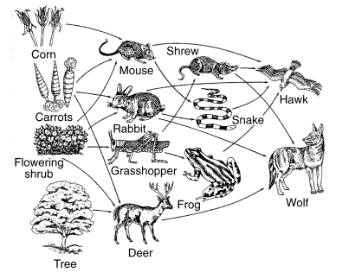  Image from: BIOLOGY by Miller and Levine | 13. In which of these organisms would you expect the concentration of DDT to be the highest?  A. tree  B. grasshopper  C. frog  D. hawk

14. Which of the following environmental problems was the KYOTO ACCORD intended to help?
15. Burning fossil fuels causes ALL of the following EXCEPT______________________.
A. acid rain
B. global warming
C. ozone depletion
D. smog
16. Dead zones are caused by ___________________________.
A. using aerosols with CFC’'s
B. fertilizer and animal waste runoff
C. drought
D. burning fossil fuels
CLASSIFICATION Chapter 18
17.The scientific name for this animal is Panthera leo.
To which genus do lions belong?
18. The molecule found in the cell walls of Fungi which makes them different from plants is ______,
19. Organisms that “like” to live in hot environments like volcano vents would be in the DOMAIN
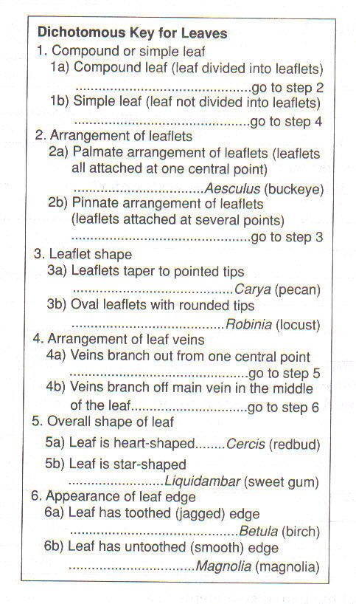 | 20. USE THE DICHOTOMOUS KEY BELOW TO CLASSIFY THIS LEAF  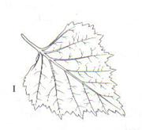
EVOLUTION Chapters 15, 16, 17
21. ALL of the following support Darwin's Theory of Evolution EXCEPT ______________
A. similarities between a whale flipper and a bat wing
B. telomeres in the middle of human chromosome #2
C. loss of the ability to make vitamin C in humans and other primates
D. fossil record
E. development of antibiotic resistant bacteria
F. Inheritance of acquired traits
22. When Darwin returned from his voyage, he __________________________
A. immediately published his ideas about evolution
B. wrote about his ideas but waited many years to publish them
C. realized his ideas about evolution were wrong
D. copied the evolutionary theory of Wallace
EVOLUTION OF POPULATIONS CHAPTER 16 & 17-4
23. Which of the following graphs shows a population that has undergone stabilizing selection?

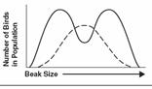 | 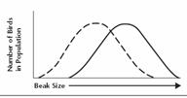 | 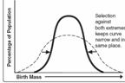
A | B | C
24. A bell curve is typically seen in a graph of phenotypes for a ________________ trait.
25. Name the 5 conditions required to maintain genetic equilibrium under the HARDY-WEINBERG PRINCIPLE.

ANSWERS:
1. Glucose
2. thylakoid
3. oxygen
4. H⁺
5. C. glycolysis → Krebs cycle → Electron Transport
6. A glucose molecule is broken down into 2 pyruvic acid molecules
7. oxygen
8. D. mitochondrial matrix
9. producer (autotroph)
10. denitrification
11. carbon cycle
12. humans get their nitrogen from food
13. D. hawk
14. Global warming
15. C. Ozone depletion
16. B. fertilizer and animal waste runoff
17. Panthera is the genus; leo is the species
18. chitin
19. Archaea
20. Betula (birch)
21. F, Inheritance of acquired traits
22. B. wrote about his ideas but waited many years to publish them 2.
23. C shows stabilizing selection
24. founder effect
25. No mutations
No natural selection
No migration in or out
Large population
Random mating

